1. 
2. When dealing with long running task, we want to give user an availability to cancel the task.   
   NOTE: ThreadDemo.java is main file whose show() would be called.
3. 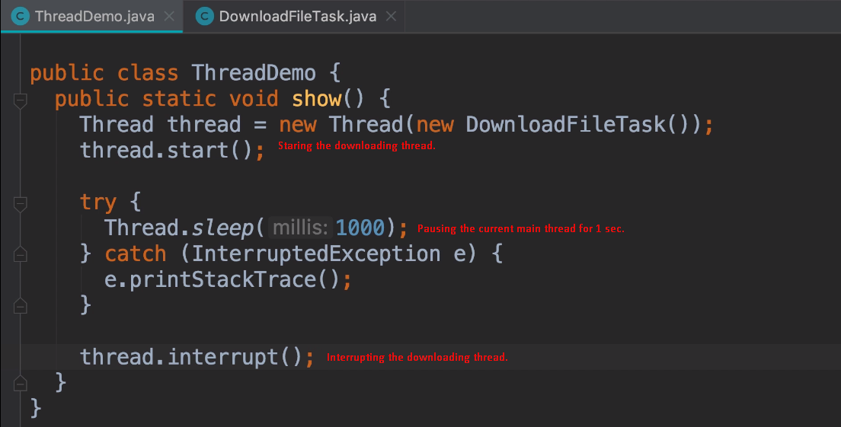  
   **NOTE**: Calling interrupt() method on a thread is just a request to the thread to terminate its ongoing execution. It’s up to the thread to decide what to do with the request. 